Section 18: AWS Monitoring & Audit: CloudWatch, CloudTrail and Config

AWS Solution Architect Associate

# CloudWatch

## 202. AWS CloudWatch Metrics

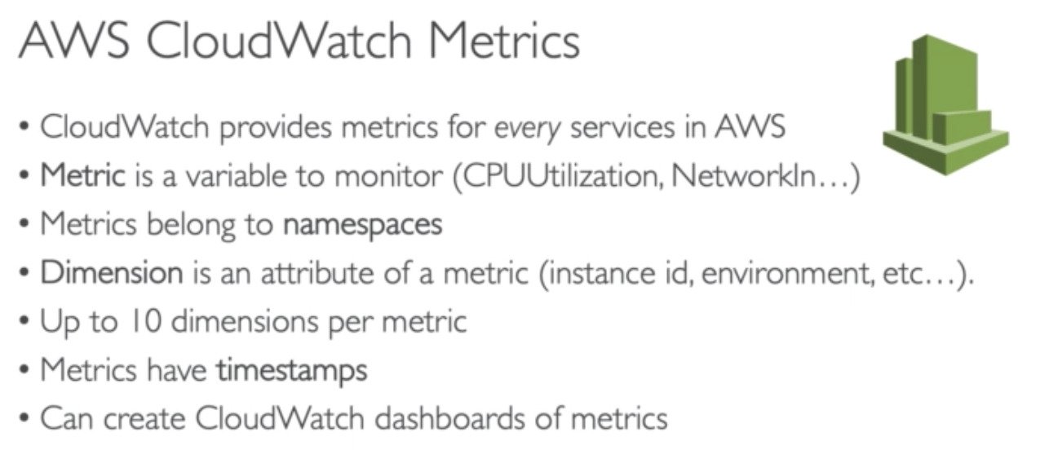

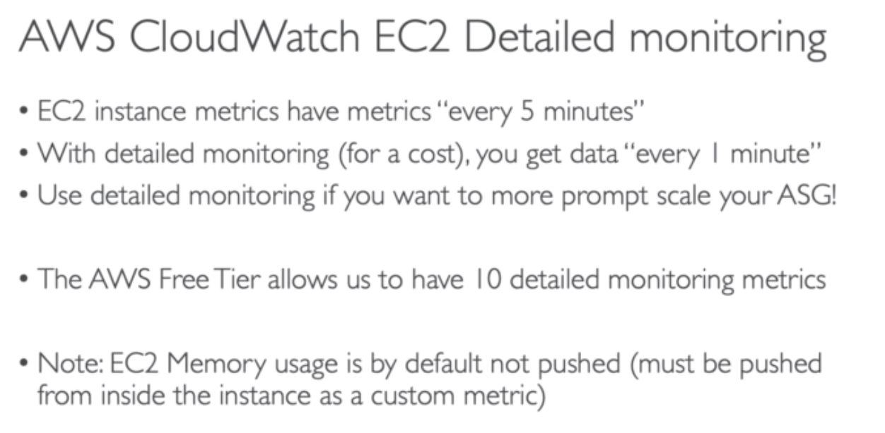

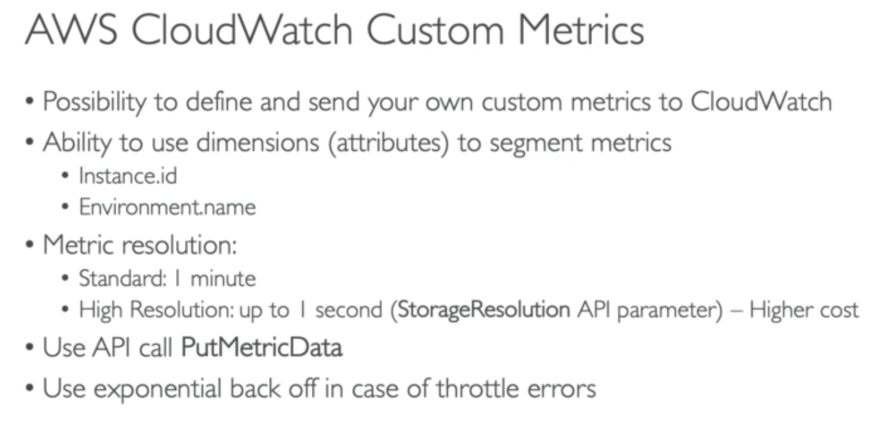

## 234. AWS CloudWatch Dashboard

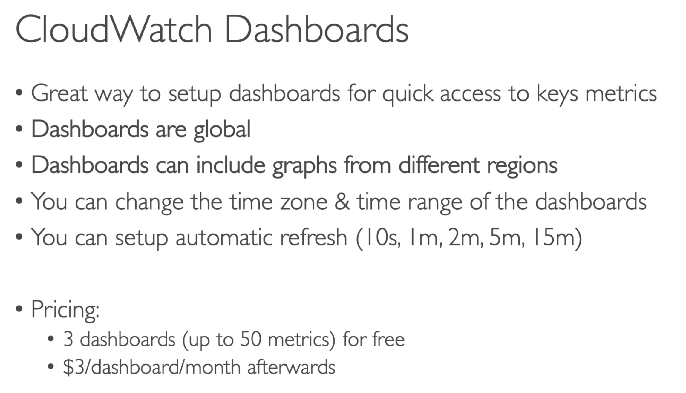

**Remember:

ExamTip:

- Dashboards are global and they can include graphs from different regions.

- Exam may ask how to create global dashboard – hands on steps

## 235. AWS CloudWatch Logs

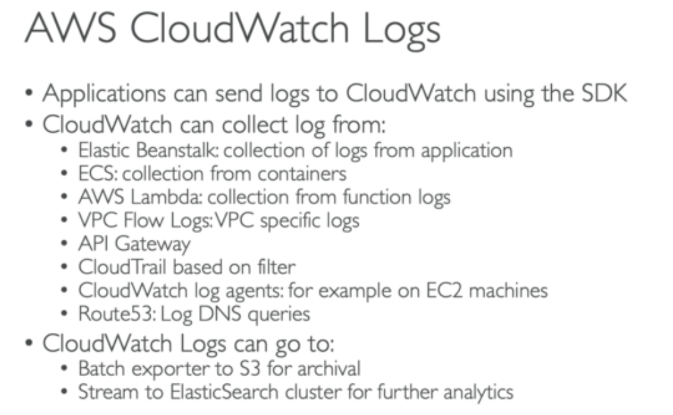

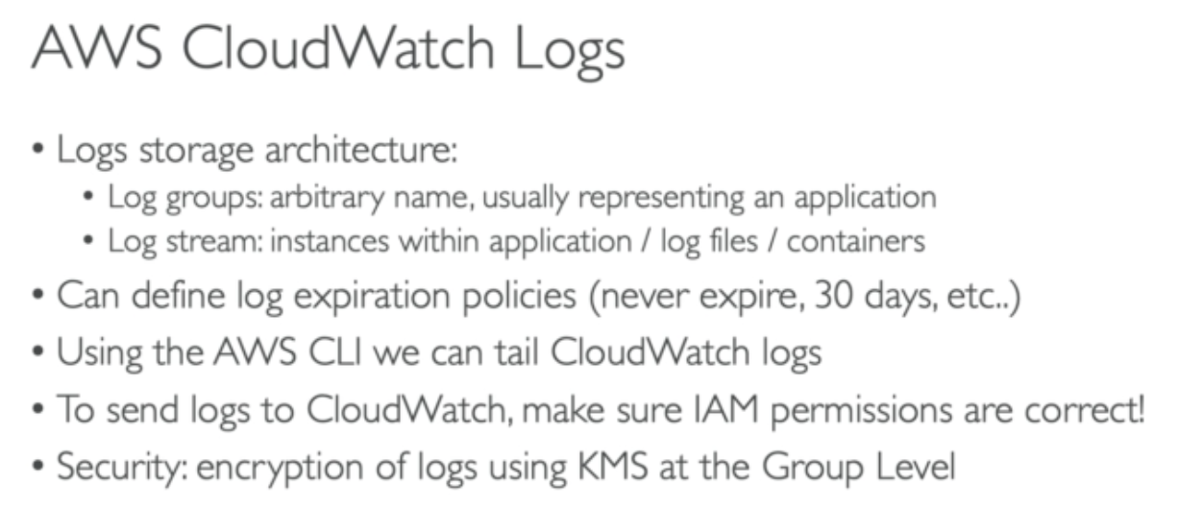

You pay for data retention in CloudWatch. More data you store, more you pay… so setup log expiration policy.

It is a good strategy to –

- retain CloudWatch logs for 30 day,

- then export the data from CloudWatch and save them in S3

- Delete logs from CloudWatch in time to time.

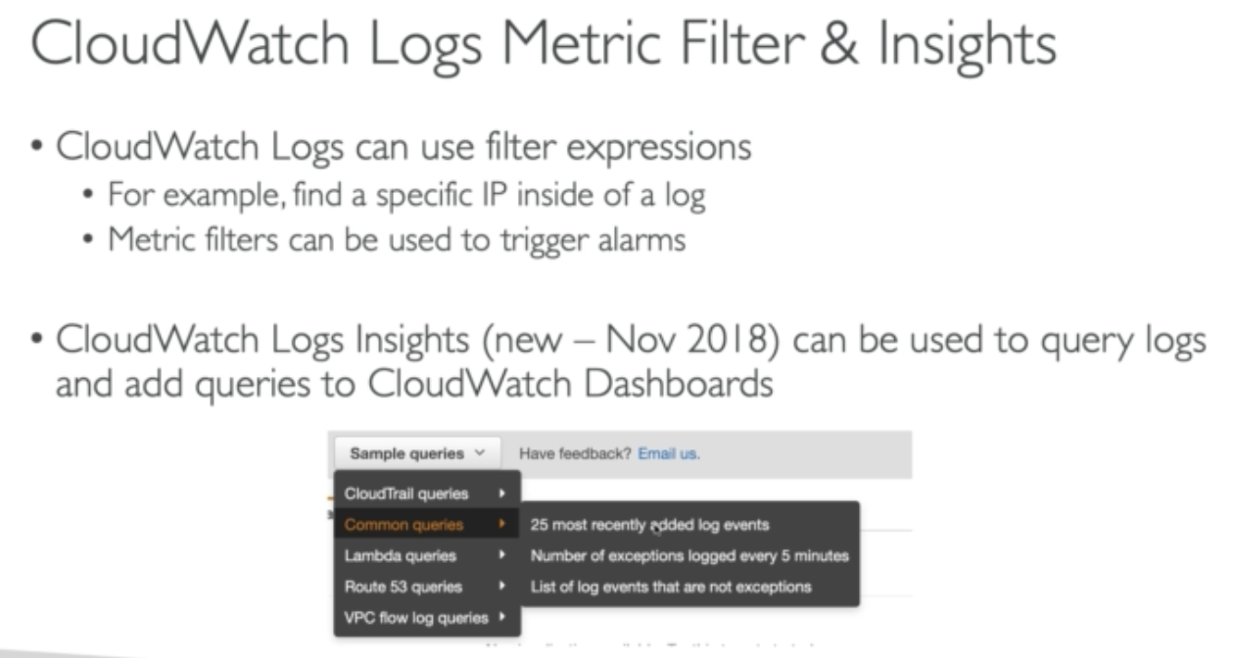

You can add queries to filter CloudWatch logs…

## 236. CloudWatch Agent and CloudWatch Logs Agent

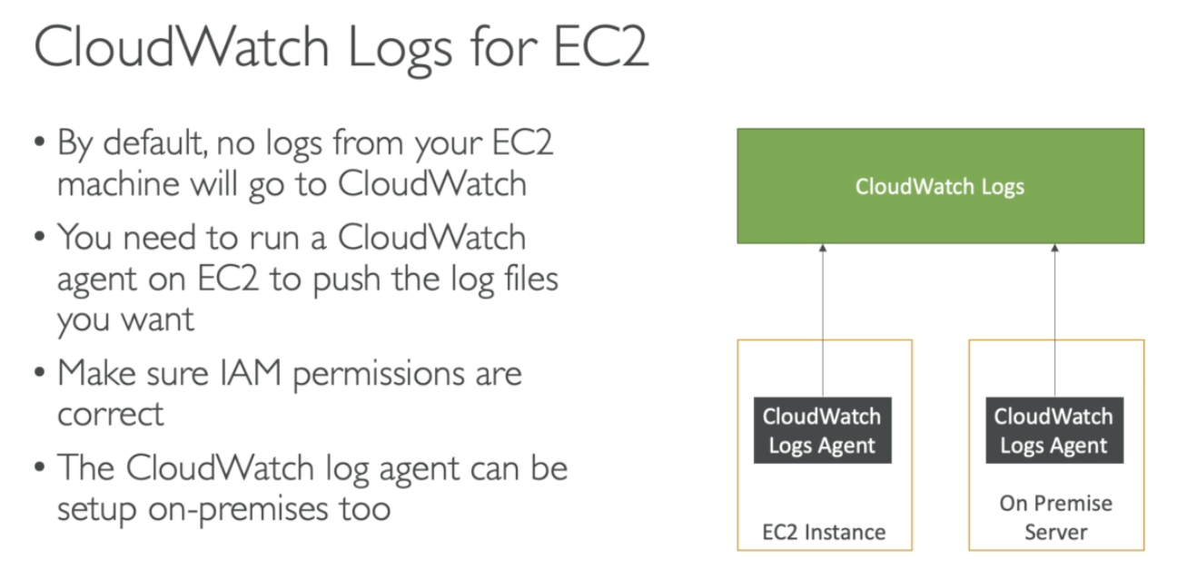

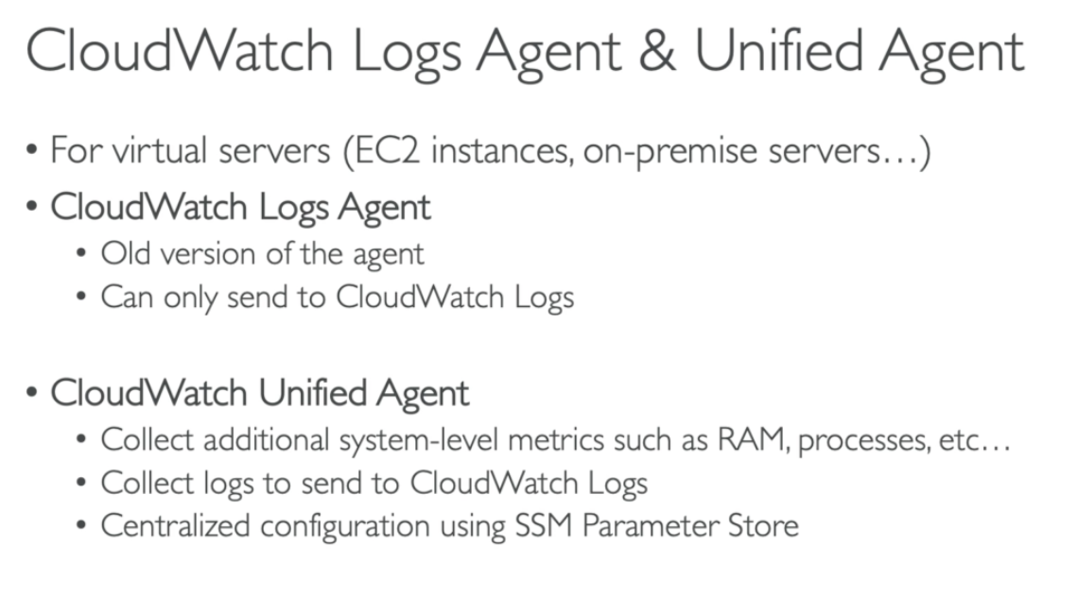

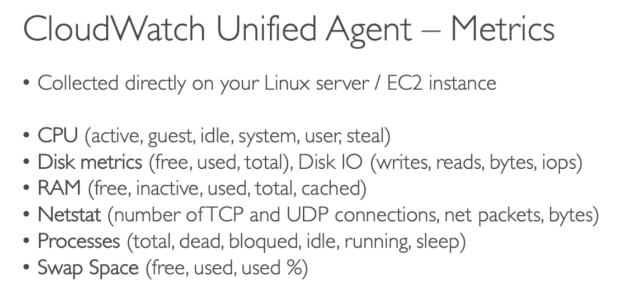

**Not important to remember for exam…

## 206. AWS CloudWatch Alarms

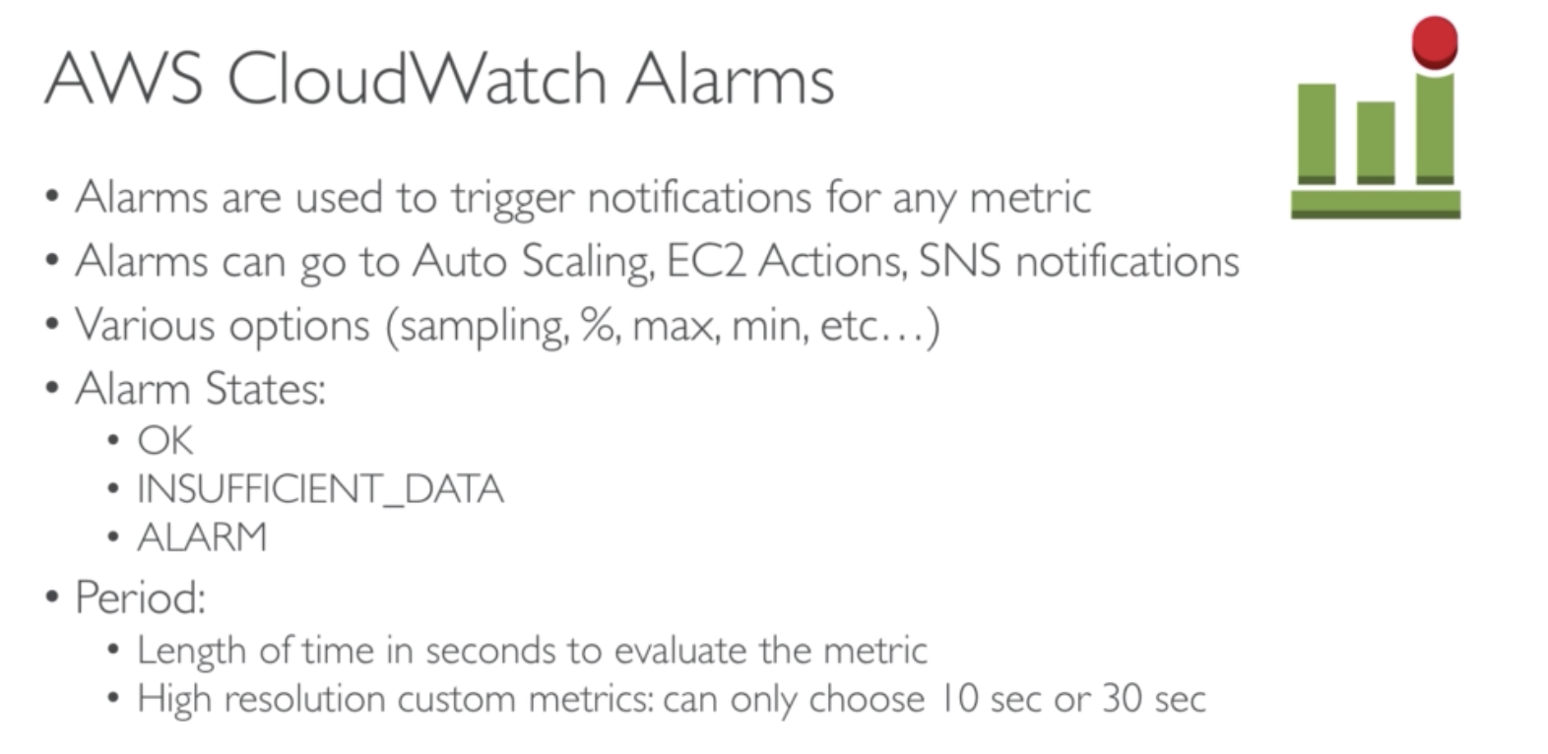

## 207. EC2 Instance Recovery with CloudWatch Alarms

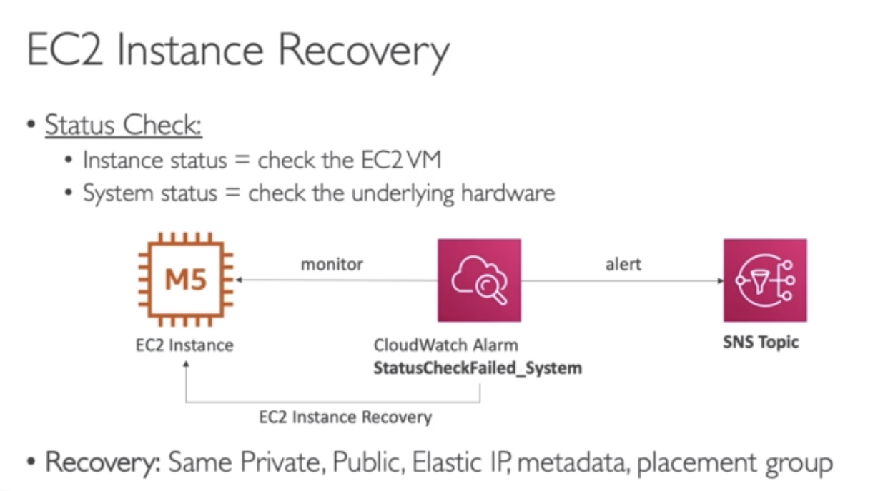

Exam Q: How can you recover your EC2 instance medically?

CloudWatch Alarm will check the status check of the EC2 instances. If alarm is triggered, the action of that alarm will be EC2 instance recovery.

The alarm can send a notification to SNS Topic.

* Instance recovery means: you will have the same Private IP, Elastic IP etc. as before.
* But any data that was stored in the instance store will not be kept.
* If you have EBS volume, then the data will be kept because data will reside in EBS volume.

## 208. AWS CloudWatch Events

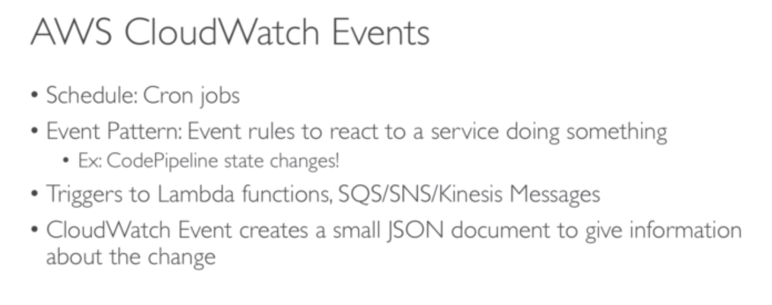

# CloudTrail – Monitoring and Audit

## 209. AWS CloudTrail

### Overview

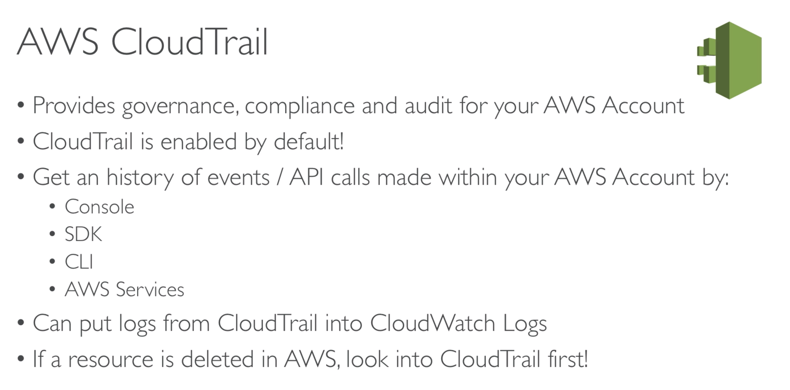

### Diagram

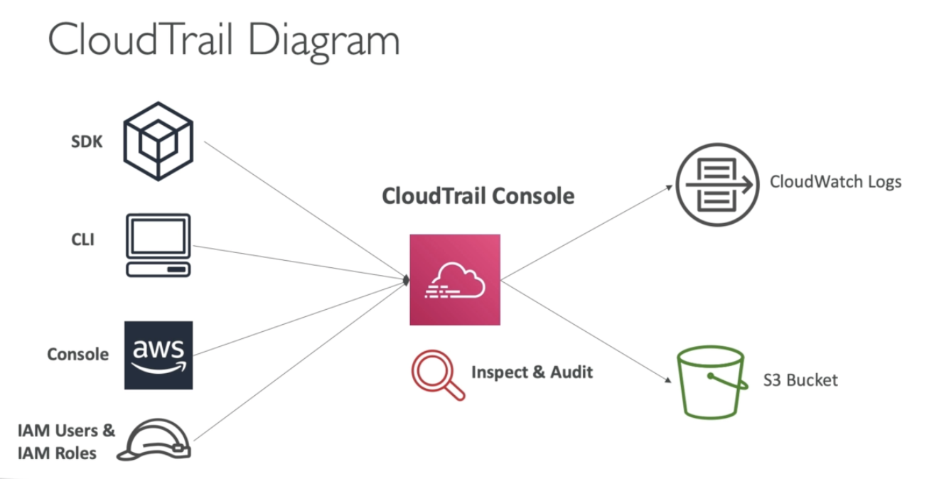

### CloudTrail Insights

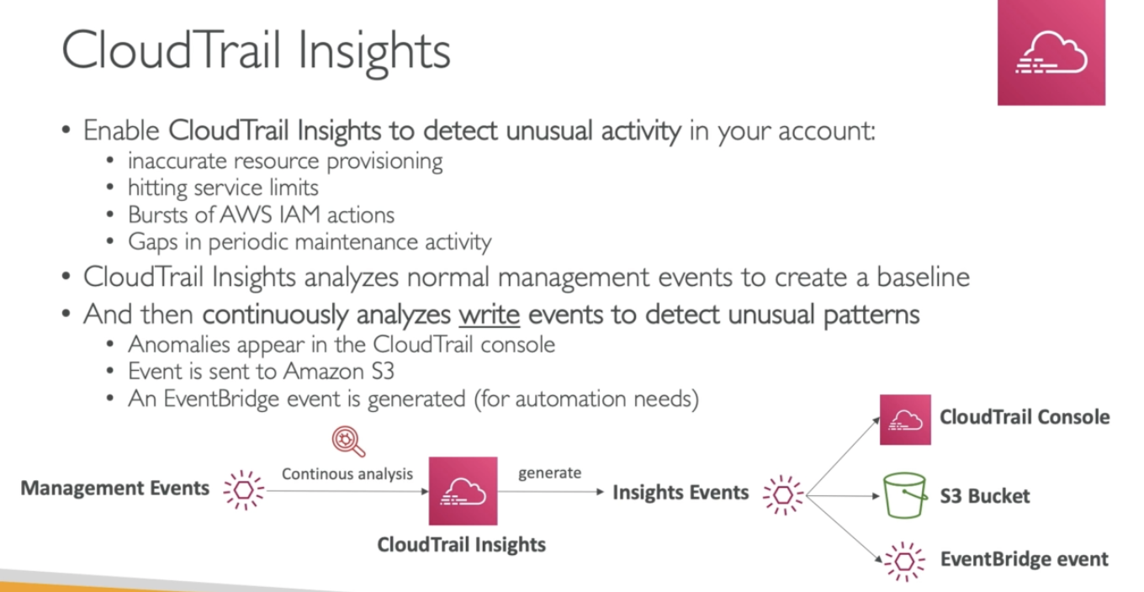

### CloudTrail Events Retention

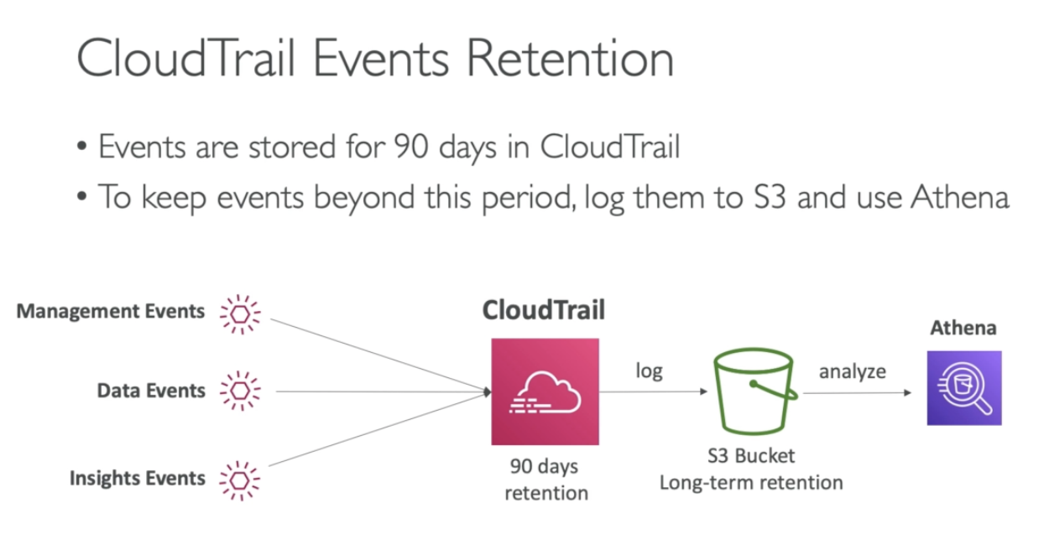

# Config

## 210. AWS Config - Overview

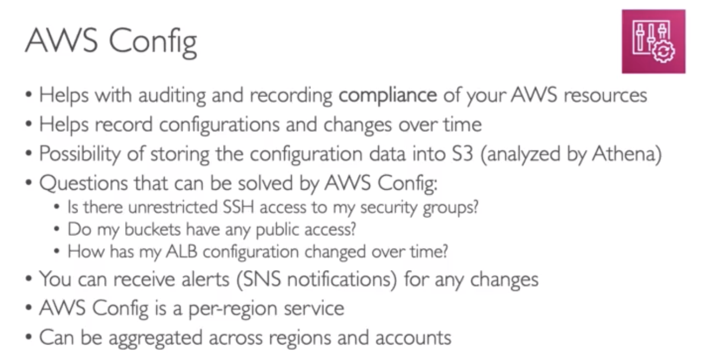

### Config Resource

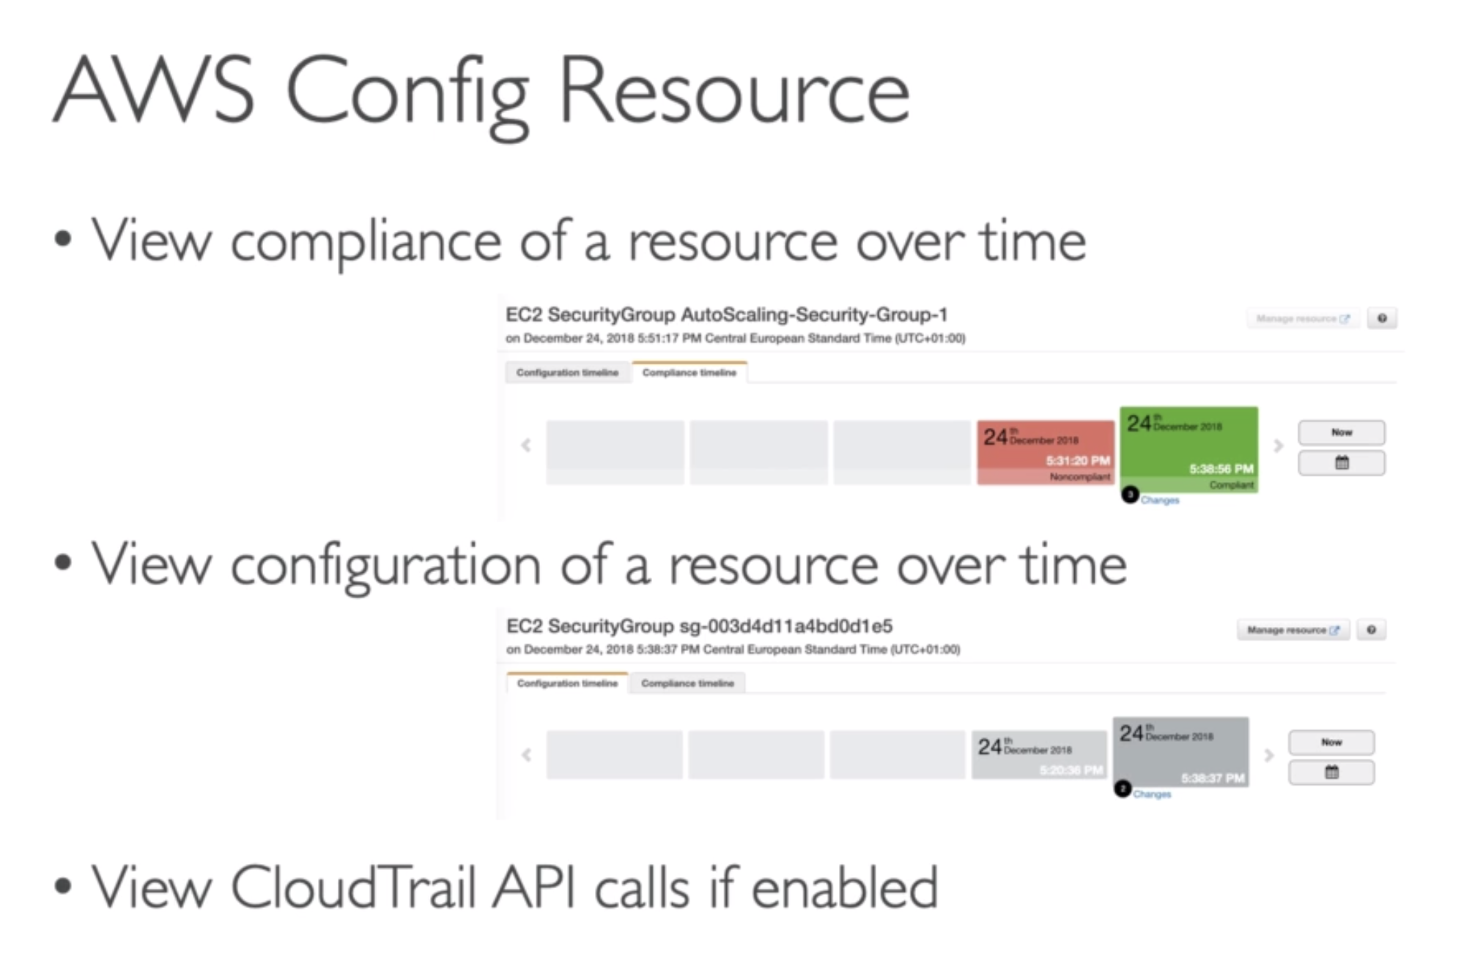

### Config Rules

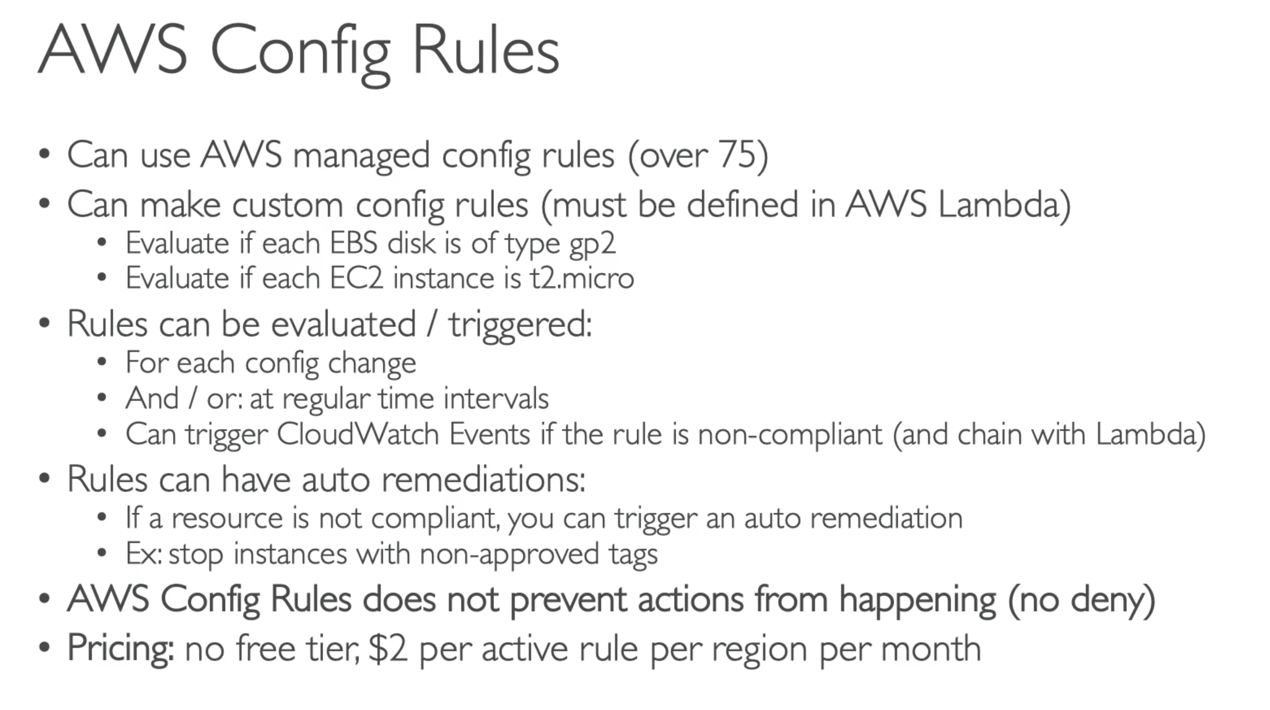

# 211. AWS Config – Hands On

# 212. CloudTrail vs CloudWatch vs Config

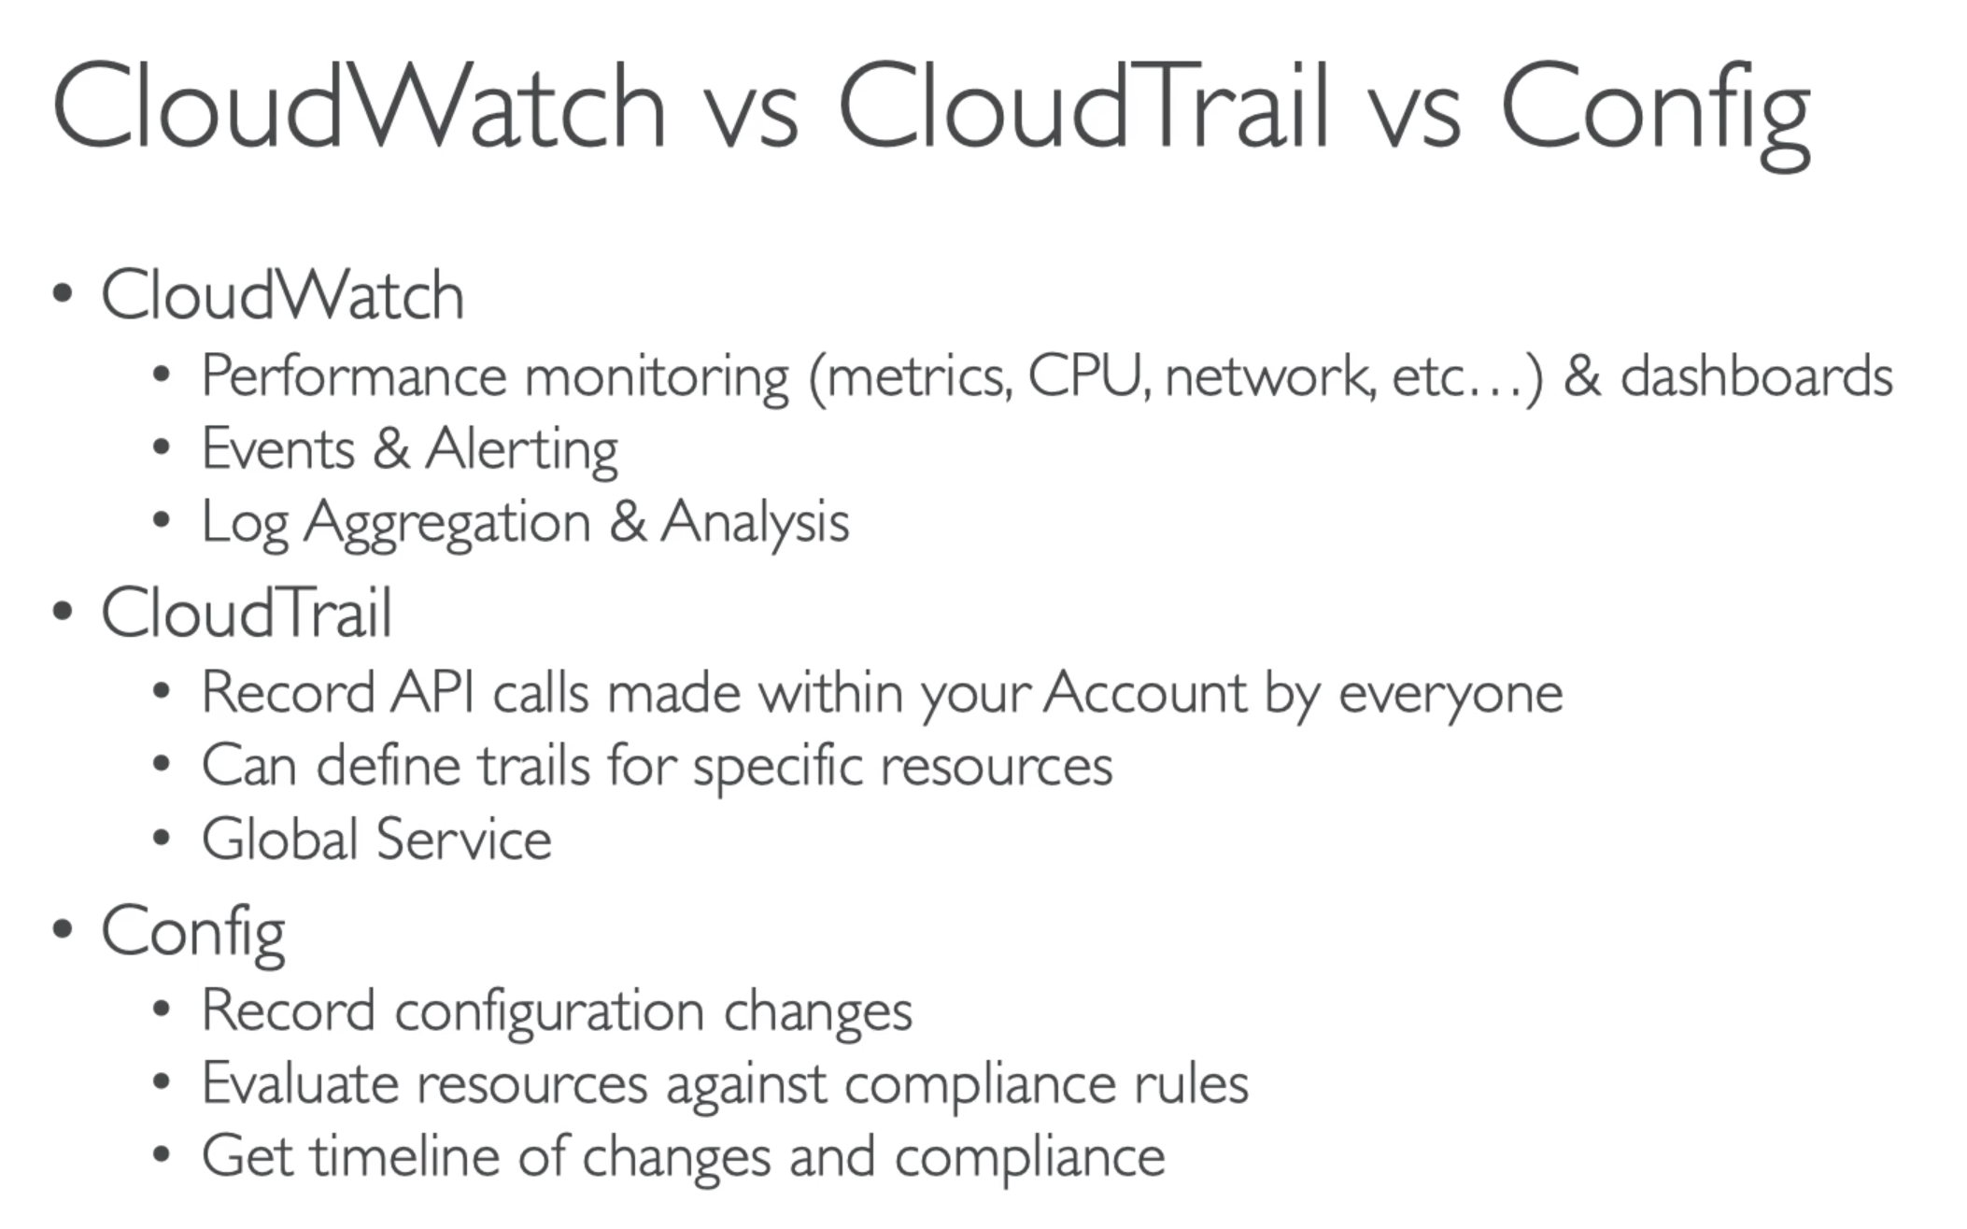

ExamTip:

Popular exam qn – make the distinction between CloudWatch, CloudTrail and Config

